**Brew Craft Variable capacity stainless steel tanks**



Stainless steel variable capacity tanks provide a versatile alternative for winemakers. Utilizing a floating lid, variable size batches of wine may be processed when the availability of ingredients is limited. The variable capacity tanks are supplied with a floating lid which is sealed with an inflatable gasket similar to a bicycle tube. When inflated, the tube seals the lid against the sides of the tank to provide a dust free and oxygen free environment. The tank is also supplied with a stainless steel ball valve with a tapered nozzle and a two stage ball air lock which is threaded into the lid. The tanks provide a safe option of oxygen free storage especially with racking of wines and reduced volumes. Tanks are primarily designed for the storage of wines after primary fermentation. If the tanks are to be used for fermenting then the two way ball airlock must be replaced with a proper fermentation airlock. These tanks range in size from 100 liters to 2,000 liters with a vast array of option including stands cooling jackets, sloping & conical floors, sight volume indicators, thermometers etc……





**Tank Preparation:**

Before using the tank for the first time, inspect the lid and the inside of the tank for any burrs or rough edges that may prevent a seal or may cause damage to the inflatable gasket causing failure. Correct any deficiencies by filing the rough edges or by sanding lightly with abrasive paper. Flush all loose filings or metal shavings with water before proceeding with the sanitizing. Stainless steel tanks are easy to maintain and clean. The tank should be thoroughly cleaned and sanitized before each use. The tank should be rinsed with hot water on the inside surface first then prepare a solution of **Brewcraft “COLD WATER (ECD) equipment cleaner/Deodorizer ,**

A solution of citric acid as a final rinse to prepare the tank is essential (50gr/4 liters of warm water ) applied to the inside of the tank, and again thoroughly rinsed. The lid, valve, air lock and other components should be sanitized at this time with a brewing steriliser available from you local **Brewcraft stockist**

**DO NOT USE** – sulfite ( Sodium or Potassium Metabisuphite) or chlorine based products, these chemicals attack the stainless steel (especially AISI 304) and will cause pitting, weakening the tank and making it more difficult to clean thoroughly as well as reducing the ability of the tank to seal properly.

**DO NOT USE** – abrasive cleaners, powders or detergents on the tank or any of the stainless steel components.

The tank should be mounted on a stainless steel stand available from the supplier or on a fabricated platform of sufficient strength to support the weight of the wine. As an example, a 200 litre tank filled to the top can weigh over 250kg, so it is very important to have the tank placed on a substantial base.



Since the tanks are in a permanent position when in use, purchase of or having access to a suitable wine transfer pump is highly recommended. After the tank has been filled, do not attempt to move or push against the tank. Injury may result as well as damage to the tank walls preventing proper sealing and may render the tank useless .



**Tank Use:**

After the tank has been cleaned and prepared for use, the ingredients may be added in the usual manner for winemaking and processing. Stainless steel tanks may be used from the primary stage as well as long term storage and bottling. The tank may be utilized for maceration of red grapes, as the lid is removable; access to the cap is simplified.

After the juice and ingredients have been placed into the tank, place the lid over the must and partially inflate the gasket. Raise the lid one inch to clear the juice before fully inflating the gasket. This will prevent back-flow of the must through the airlock, especially during the primary stage of fermentation.

**NOTE** : for primary fermentation inflation of the gasket. (see below for instructions – “Assembly of variable capacity tank”). The air lock uses two marbles to release CO2 gas while keeping dust and contamination out. The marbles seal the lock in such a manner that a vacuum may be created whenever wine is extracted from the ball valve. It is important to release the lid when the ball valve is opened. If the seal is not relieved, the sides of the tank may buckle, and the tank may collapse causing possible failure.

When utilized for long term storage of wine it is best to first wipe the inside of the lid with a sterilizing solution available from your local Brewcraft stockist. This will repress wild yeast or similar spoilage organisms from propagating. Repeat the procedure whenever the lid is disturbed or removed. In this instance, the lid should be placed directly on top of the wine to prevent, or at least minimize the growth of wild yeast film on the wine.

**Long Term Storage:**

When the tank is placed into seasonal storage, care should be taken to prevent denting or crushing the container. Do not lay the container on its side or place foreign objects on the container when it is in the upright position. Failure to follow these recommendations may prevent the lid from sealing properly. Cover the tank with a suitable cover such as polyethylene sheeting to prevent dust and debris from accumulating inside the tank.



**Assembly of Variable Capacity Tank Lid:**

There are six components of a floating lid: stainless steel lid, white plastic air valve, inflatable gasket, soft vinyl tubing, screw clamps and air pump. Assembly of the lid is very simple and is similar to installing a tube on a bike.

1) Install the inflatable gasket on the lid. Put the gasket stem through the small hole in the lid lip and stretch the gasket around the lid. The gasket will be very tight when first applied. This is normal and is particularly true for small diameter tanks. The gasket stretches upon inflation. To make assembly easier, simply attach the gasket to the pump and inflate/deflate once or twice before attaching the gasket to the lid

2) Install the white plastic air valve.

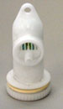

3) Attach the air pump to the gasket using the vinyl tubing and screw clamps.

4) Inflate the gasket and check for leaks at the connections of tubing/gasket and tubing/pump. Use either soapy water (2 parts water/1 part dish soap) or immerse in water if possible.

5) The vast majority of leaks are at the connection of the vinyl tubing/gasket or pump/vinyl tubing. The leak can result from either under-tightening or over-tightening of the screw clamps. It is advisable to annually cut the ends off the vinyl tubing or replace the vinyl tubing as it dries out and becomes less pliable.

6) Use Teflon tape to seal threaded connections .

7) Fill tank with water initially to ensure all connections are sealed.

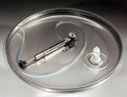

8) Install floating lid. Simply float the lid on the wine (like a boat) and inflate with gasket to make the seal. Inflate only to make a seal and never exceed 0.8 bar. The green zone on the gauge is the maximum pressure zone. Typically 0.5 bar is sufficient but it will depend on the tank size. ( the pumps do vary and it may just be a RED line which will signify the maximum pressure )

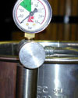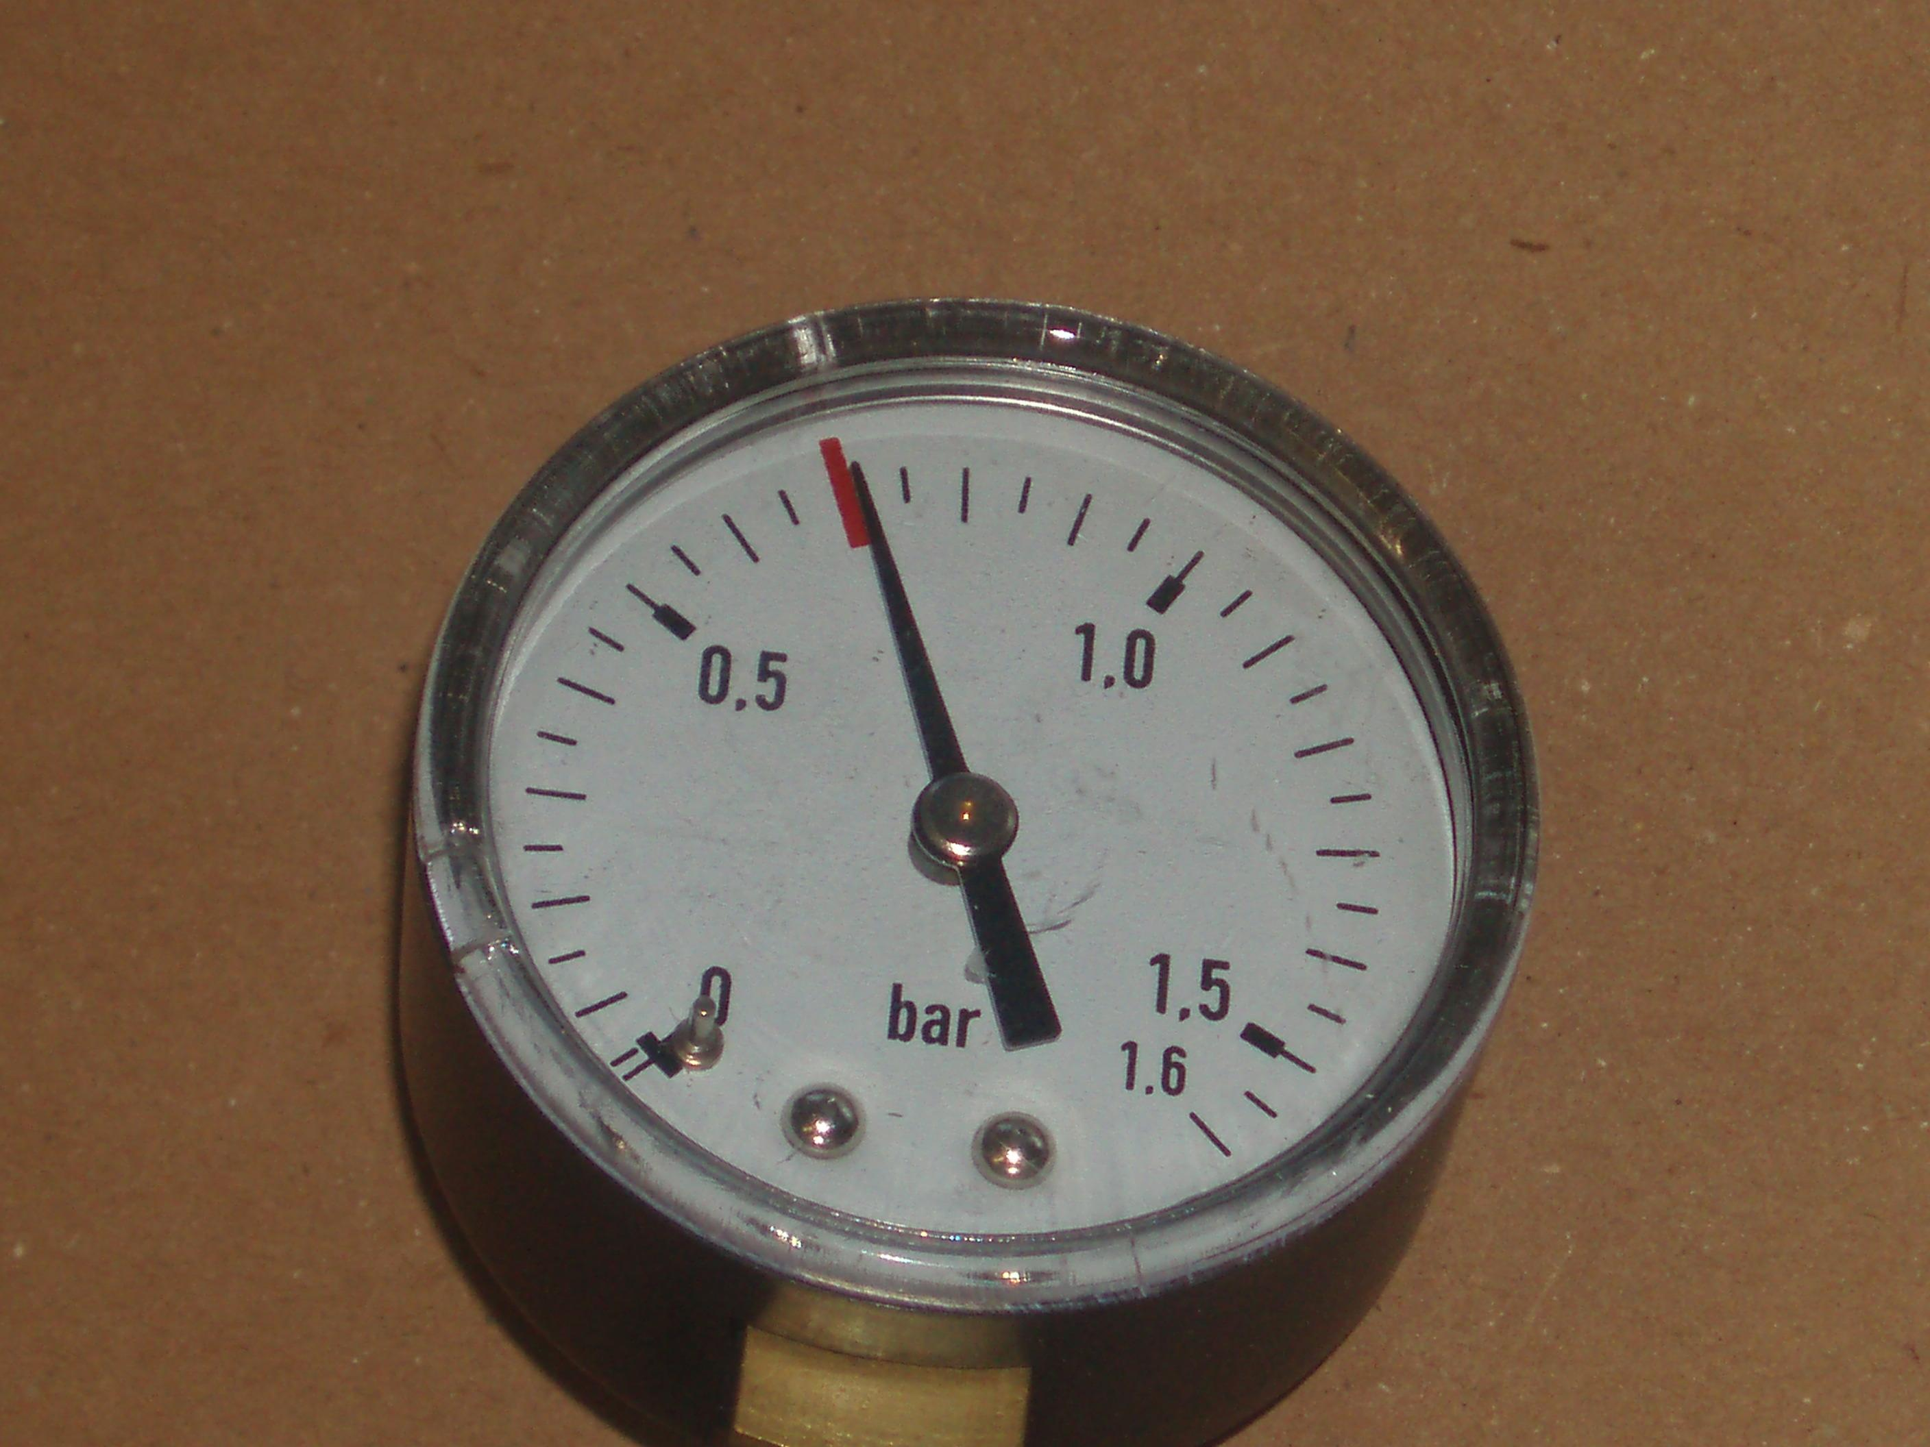

**Over inflation can result in one of two problems:**

1)Forcing wine up through the air valve and

2) lid slips up the side of the tank.

**Problems & remedy**

What to do if your tank loses pressure:

Find the leak by using soapy water or by immersing the gasket in water. The vast majority of leaks are at the connection of the vinyl tubing to the gasket stem or to the pump. Check these carefully first. If necessary, check the pump by disconnecting it from the system, pump it up with your finger over the outlet, close valve, and immerse in water.

Note that the gauge will fill with water first which causes bubbles—this is not a leak. Wait until the gauge is filled with water then inspect carefully the connection of the gauge to the pump housing. If this leaks, simply remove gauge and apply teflon tape.

**Pump Note.** The pump valve has three positions. The best way to understand it is to simply experiment with it. Fully-closed seals off the gasket from the pump, except for the gauge. Fully-open deflates the gasket. Partially-open is the position used to inflate the gasket.